18.74: (See Example 12.5 for calculation of the escape speeds)
a) Jupiter:
Earth:

b) Escape from Jupiter is not likely for any molecule, while escape from earth is possible for some and hence possible for all.

c) The radius of the asteroid is 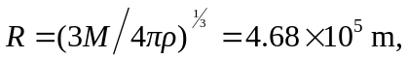 and the escape speed is 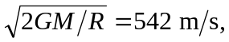 so there can be no such atmosphere.

